# K.J. Somaiya College of Science & Commerce Vidyavihar (E), Mumbai – 400077.

**Autonomous**

**Affiliated to University Of Mumbai**



**PROJECT REPORT ON**

ONLINE FOOD ORDERING SYSTEM

**SUBMITTED BY**

**DIPESH LAXMIDAS KHICHADA**

**T.Y.B.SC (COMPUTER SCIENCE)**

# UNIVERSITY OF MUMBAI 2020-2021

**PROJECT GUIDE MISS. Suchita Mandhare**

K.J. Somaiya College of Science & Commerce

Vidyanagar, Vidyavihar, Mumbai – 400077. Autonomous – Affiliated to University Of Mumbai

## DEPARTMENT OF COMPUTER SCIENCE

**(2020-2021)**

CERTIFICATE

This is to certify that Mr. DIPESH KHICHADA of T.Y.B.Sc. [Computer Science] Semester –VI, Seat no.2009819 has successfully

completed the project entitled as An E-Food Ordering Web Application to provide Online Food Ordering System.

Level during the academic year 2020 – 2021.

Internal Guide

Date:

|  |  |  |
| --- | --- | --- |
| Course coordinator | College Seal | External Examiner |
| B.Sc.(CS) |  |  |
| Date: |  | Date: |

**ACKNOWLEDGEMENT**

Achievement is finding out what you would be doing rather than what you have to do. It is not until you undertake such a project that you realize how much effort and hard work it really is, what your capabilities are and how well you present yourself or other things. It tells you how much we rely on the efforts and goodwill of others. It gives me immense pleasure to present this report towards the fulfillment of my project.

It has been rightly said that we are built on the shoulder of others. For everything I have achieved, the credit goes to all those who had helped me to complete this project successfully.

I take this opportunity to express my profound gratitude to management of K. J. Somaiya College of Science and Commerce for giving me this opportunity to accomplish this project work.

A special vote of thanks to my teachers, **Miss. Kirti Amberkar, Miss. Mousmi Pawar**

**,Miss.Suchita Mandhare, Mrs. Mohammad Bilal Shaikh and Miss. Monali Deshpande** and Head Of Department **Mrs. Prakash Patil** for her most sincere, useful and encouraging contribution throughout the project span.

Finally I would like to thank all my friends(**Harsh Chheda, Uday Haria**) and the entire Computer Science department who directly or indirectly helped me in completion of this project and to my family without whose support, motivation and encouragement this would not have been possible.

# INDEX

|  |  |  |
| --- | --- | --- |
| **SR. NO.** | **TOPIC** | **PAGE NO.** |
| 1 | Project overview | 6 |
| 2 | Description of System | 7 |
| 3 | Limitations of present system | 8 |
| 4 | Proposed system and its advantages | 9 |
| 5 | Stakeholders | 10 |
| 6 | Gantt chart | 11 |
| 7 | Technologies Used and their Description | 12 |
| 8 | Event Table | 14 |
| 9 | Use case Diagram and Basic Scenarios & Use Case Description | 15 |
| 10 | Entity-Relationship Diagram | 17 |
| 11 | Data Flow Diagram | 18 |
| 12 | Class Diagram | 19 |
| 13 | Sequence Diagram | 20 |
| 14 | State Diagram | 22 |
| 15 | Menu Tree | 23 |

|  |  |  |
| --- | --- | --- |
| 16 | List of Tables with Attributes and Constraints | 24 |
| 17 | System Coding | 25 |
| 18 | Screen Layouts and Report Layouts | 44 |
| 19 | Future Enhancements | 50 |
| 20 | Bibliography | 51 |

**PROJECT OVERVIEW**

The Simple Online Food Ordering System has the admin side and visitor/client-side. The admin will manage all the data needed for the website more importantly the list of available menus. The client will browse the website, explore and choose his/her desired menu's and save it to cart for later checkout. After that, the client will go to the cart, review his/ her order, confirm the delivery address and other information, and place his/ her order.

Online ordering system that I am proposing here, greatly simplifies the ordering process for both the customer and the restaurant. System presents an interactive and up-to-date menu with all available options in an easy to use manner. Customer can choose one or more items to place an order which will land in the Cart. Customer can view all the order details in the cart before checking out. At the end, customer gets order confirmation details. Once the order is placed it is entered in the database and retrieved in pretty much real time. This allows Restaurant Employees to quickly go through the orders as they are received

and process all orders efficiently and effectively with minimal delays and confusion.

**PRESENT SYSTEM**

Currently in the restaurant all the work is done manually. When a guest makes a reservation at a table or orders some food, everything is written in the restaurant register even the customer details are written in the register. At the time of payment calculations of the bill is done manually. Doing all the work manually and storing information on the register takes much time and wastes much precious hours. Manually calculation of bills is also error prone. If the management wants fast bookings and order from the customers it is difficult to do it manually.

In the existing system, It is difficult to manage so many staff and customers manually and to store records of the customer in a register.

# LIMITATIONS OF PRESENT SYSTEM

# 

# In the present scenario, people have to physically visit the hotels or restaurants for eating food and have to make payment through cash mode most of the times due to unawareness of advanced technologies at certain places.

# The traditional food ordering procedure is not efficient enough for hotels and restaurants, as they have to deal with the crowd, in their restaurant.

# The old methods can be classified into categories which are paper grounded and verbal grounded.

# The waiter comes and pens down foods that customers order and pass the food list containing paper to the chefs or cooks in the kitchen for further process.

# Owner’s point of view is maintaining data records and the accounts in the physical file are difficult and tedious work to do.

# It is full of risk as anyone can access it and modify the data.

# 

**PROPOSED SYSTEM AND ITS ADVANTAGES**

This Online food ordering system is a website where the user can go through the website and order food online.It has a bunch of benefits from various points of views. As this online application enables the end users to register to the system online, select the food items of their choice from the category list, and order food online.It has a food delivery option user can order food online with their correct address and the delivery boy will deliver the food to the customer address. System also has an add to cart option where users can add food items that they want to order and later make payment .The payment can be made through online mode or at the time of home delivery depending upon the customer’s choice and convenience. The selection made by the customers will be available to the hotel reception or to the person handling work assignment.

Now this same person will assign the orders to the specialist chef to be completed within a fixed duration of time. As soon as the chef prepares the food, the later person forwards the parcels to the delivery persons assigned with the location and customer identity of the customer along with the bill status.

**ADVANTAGES OF PROPOSED SYSTEM**

This order food online project aimed at developing an online food ordering website which can be used in small places, medium cities firstly and then on a large scale.

The most important advantage of food delivery is providing food whenever or wherever you want. Nowadays people are too busy at times, but food delivery service helps them to grab a bite in their busy schedule. This System is very advantageous to overcome the traditional method, the advantages of are as follows:

* Improve customer loyalty.
* Makes the ordering process easier.
* Efficient customer and order management.
* Monitor your expenses incurred in real time.
* Free and cheap marketing.
* Acquire customers who only order online.
* The convenience of mobile ordering.

# STAKEHOLDERS

A stakeholder is either an individual, group or organization who is impacted by the outcome of

a project. They have an interest in the success of the project, and can be within or outside the

organization that is sponsoring the project.

Following are the stakeholders for the project

1. Developer

Developer is the main person of the system. Developer knows all the information about

the system. Developer deals with managing the user records.

2. User

User is the one who uses this application to get benefits from the application. Example:-

Student, Teachers etc

# GANTT CHART

A Gantt chart, commonly used in project management, is one of the most popular and useful ways of showing activities (tasks or events) displayed against time. On the left of the chart is a list of the activities and along the top is a suitable time scale. Each activity is represented by a bar; the position and length of the bar reflects the start date, duration and end date of the activity.



**System Analysis**

**System Design**

**System Coding**

**System Implementation**

**Preliminary Phase**

**April**

**March**

**February**

**January**

# TECHNOLOGIES USED AND THEIR DESCRIPTION

# 

**Front end: HTML, CSS, JavaScript**

1. HTML: HTML is used to create and save web document. E.g. Notepad/Notepad++
2. CSS : (Cascading Style Sheets) Create attractive Layout
3. Bootstrap : responsive design mobile freindly site
4. JavaScript: it is a programming language, commonly use with web browsers.

**Back end: PHP, MySQL**

1. PHP: Hypertext Preprocessor (PHP) is a technology that allows software developers to create dynamically generated web pages, in HTML, XML, or other document types, as per client request. PHP is open source software.
2. MySQL: MySql is a database, widely used for accessing querying, updating, and managing data in databases.

### **Software Requirement**

### WAMP Server  refers to a solution stack for the Microsoft Windows operating system, created by Romain Bourdon and consisting of the Apache web server, OpenSSL for SSL support, MySQL database and PHP programming language.

* Sublime Text is a [shareware](https://en.wikipedia.org/wiki/Shareware) [cross-platform](https://en.wikipedia.org/wiki/Cross-platform) [source code editor](https://en.wikipedia.org/wiki/Source_code_editor) with a [Python](https://en.wikipedia.org/wiki/Python_(programming_language)) [application programming interface](https://en.wikipedia.org/wiki/Application_programming_interface) (API). It natively supports many [programming languages](https://en.wikipedia.org/wiki/Programming_languages) and [markup languages](https://en.wikipedia.org/wiki/Markup_languages), and functions can be added by users with [plugins](https://en.wikipedia.org/wiki/Plugins), typically community-built and maintained under [free-software licenses](https://en.wikipedia.org/wiki/Free_software_licenses).

# 

# 

# EVENT TABLE

**Member Table**

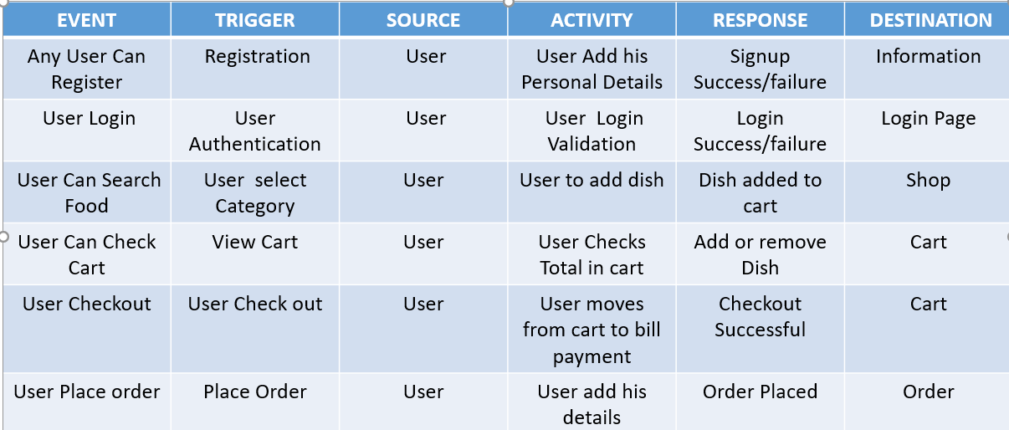

**Admin Table**

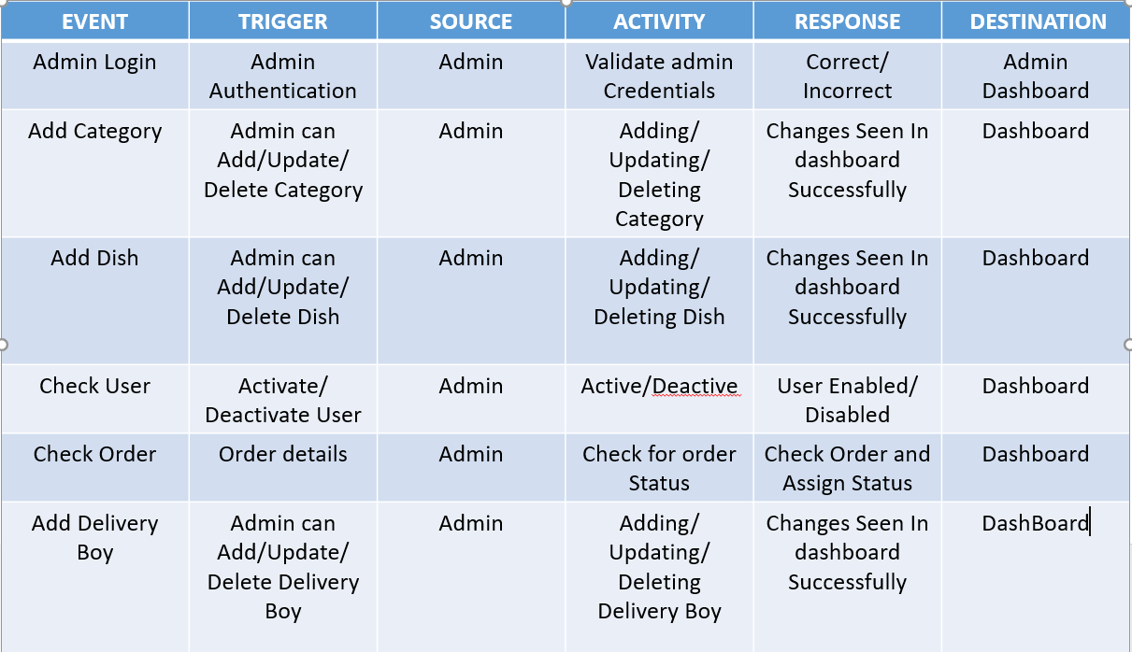

**USE CASE DIAGRAM AND BASIC SCENARIOS & USE CASE DESCRIPTION**

A Use case is a description of set of sequence of actions graphically it is rendered as an ellipse with solid line including only its name. Use case diagram is a behavioral diagram that shows a set of use cases and actors and their relationship. It is an association between the use cases and actors. An actor represents a real-world object.

# USE CASE DIAGRAM FOR ONLINE FOOD ORDERING

# 

# 

**ENTITY-RELATIONSHIP DIAGRAM**

An Entity Relationship Diagram (ERD) is a graphical tool to express the overall structure of a database. It is based on a perception of a real world which consists of a set of basic objects.

An entity is a person, place, thing or event of interest to the organization and about which

Data are captured, stored or processed. The attributes are various kinds of data that describes an entity. An association of several entities in an Entity-Relationship model is called relationship

An ERD consists of the following major components: Rectangles: Used for representing entity types

Ellipses: Used for representing attribute

Diamond: Used for representing relationship types

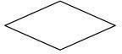

Lines: Used for linking attributes to entity types



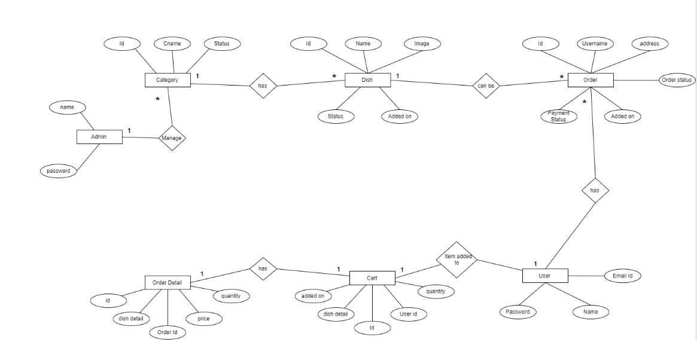

# DATA FLOW DIAGRAM

# A data flow diagram (DFD) maps out the flow of information for any process or system. It uses defined symbols like rectangles, circles and arrows, plus short text labels, to show data inputs, outputs, storage points and the routes between each destination.

DFD level 0:

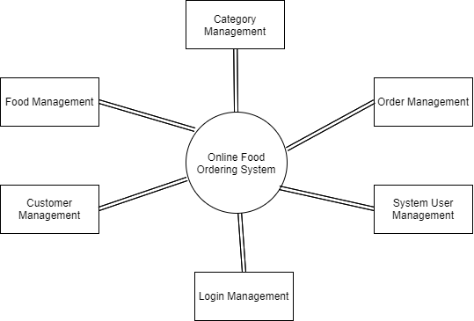

**DFD level 1:**

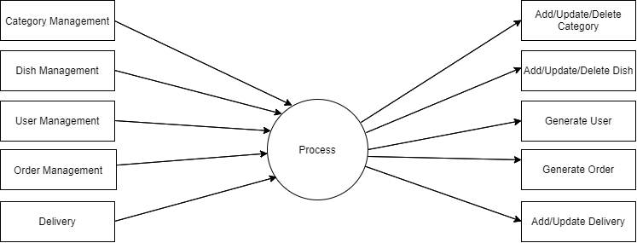

# DFD LEVEL 2:

# 

# CLASS DIAGRAM

# A class diagram in the Unified Modeling Language is a type of static structure diagram that describes the structure of a system by showing the system's classes, their attributes, operations, and the relationships among objects.

# 

**SEQUENCE DIAGRAM**

Sequence diagram and collaboration diagram are called INTERACTION DIAGRAMS. An interaction diagram shows an interaction, consisting of set of objects and their relationship including the messages that may be dispatched among them.

A sequence diagram is an introduction that empathizes the time ordering of messages. Graphically a sequence diagram is a table that shows objects arranged along the X-axis and messages ordered in increasing time along the Y-axis

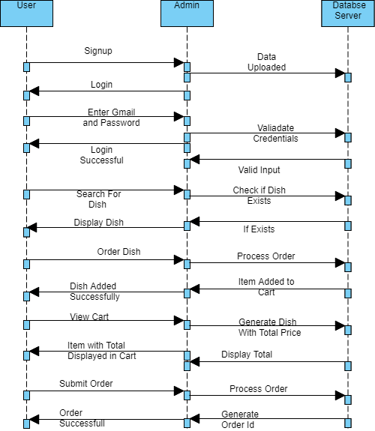

**Activity Diagram**

Activity For Admin

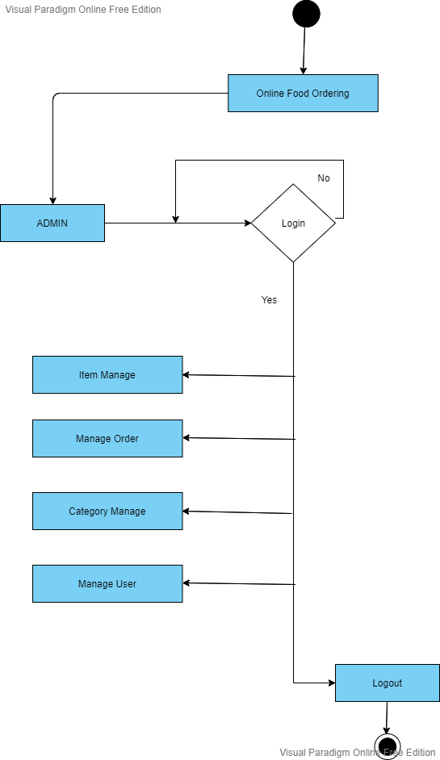

Activity for User 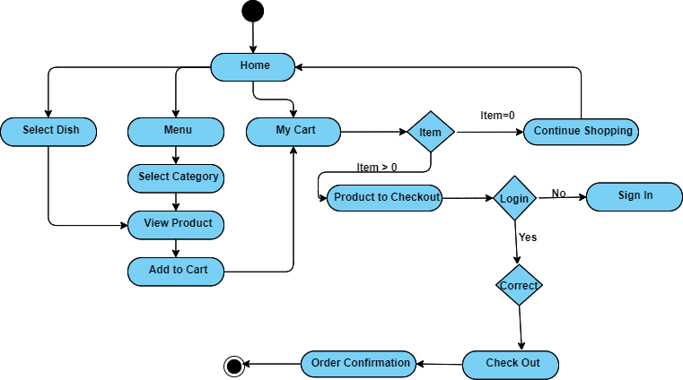

# State Diagram

# State chart diagram is also called as state machine diagram. The state chart diagram contains the states in the rectangular boxes and the states are indicated by the dot enclosed. The state chart diagram describes the behavior of the system. The state chart diagram involves stages such as login, enter details, shop, display cart details, checkout

# , and logout.

(A) State Diagram For User

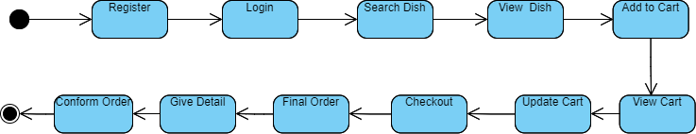

# MENU TREE

# 

**LIST OF TABLES WITH ATTRIBUTES AND CONSTRAINTS**

**ADMIN TABLE**

[SELECT](http://localhost:8080/phpmyadmin/url.php?url=https://dev.mysql.com/doc/refman/5.5/en/select.html) * FROM  `admin`

Top of Form

| **id** | **name** | **username** | **password** | **email** |
| --- | --- | --- | --- | --- |
| 1 | Admin | Admin | Admin | admin@gmail.com |

Bottom of Form

**CATEGORY TABLE**

[SELECT](http://localhost:8080/phpmyadmin/url.php?url=https://dev.mysql.com/doc/refman/5.5/en/select.html) * FROM `category`

Top of Form

| [**id**](http://localhost:8080/phpmyadmin/sql.php?db=online_food&table=category&sql_query=SELECT+%2A+FROM+%60category%60++%0AORDER+BY+%60category%60.%60id%60+ASC&sql_signature=b72056dc6c8fbfc3caee8a93fbf9af85a384e710f6cf7beae61d4daebe01fd75&session_max_rows=25&is_browse_distinct=0) | [**category**](http://localhost:8080/phpmyadmin/sql.php?db=online_food&table=category&sql_query=SELECT+%2A+FROM+%60category%60++%0AORDER+BY+%60category%60.%60category%60+ASC&sql_signature=5a443ce3ba6bfb642848cbc41c74b72fe113a7ce69d6c265884381555e0f69af&session_max_rows=25&is_browse_distinct=0) | [**order_number**](http://localhost:8080/phpmyadmin/sql.php?db=online_food&table=category&sql_query=SELECT+%2A+FROM+%60category%60++%0AORDER+BY+%60category%60.%60order_number%60+ASC&sql_signature=b167cb6af393a4c96afe444353550555d8d380c32ad3297b0550307be35aea18&session_max_rows=25&is_browse_distinct=0) | [**status**](http://localhost:8080/phpmyadmin/sql.php?db=online_food&table=category&sql_query=SELECT+%2A+FROM+%60category%60++%0AORDER+BY+%60category%60.%60status%60+ASC&sql_signature=cd800c92252afafa5d20ac8615a28465726c79e23968c6fcbe2827707cecff1f&session_max_rows=25&is_browse_distinct=0) | [**added_on**](http://localhost:8080/phpmyadmin/sql.php?db=online_food&table=category&sql_query=SELECT+%2A+FROM+%60category%60++%0AORDER+BY+%60category%60.%60added_on%60+DESC&sql_signature=b4fca9f29cfaedce43135b490e7f7946e1e04d71b1b38ae5135fd26cffa489be&session_max_rows=25&is_browse_distinct=0) |
| --- | --- | --- | --- | --- |
| 1 | South Indian | 1 | 1 | 2021-03-22 03:41:40 |
| 2 | Gujarati | 2 | 1 | 2021-03-22 03:48:26 |

Bottom of Form

**DISH TABLE**

[SELECT](http://localhost:8080/phpmyadmin/url.php?url=https://dev.mysql.com/doc/refman/5.5/en/select.html) * FROM `dish`

Top of Form

| **id** | **category_id** | **dish** | **dish_detail** | **Image** | **type** | **status** | **added_on** |
| --- | --- | --- | --- | --- | --- | --- | --- |
| 1 | 1 | South Indian | Full Dish | 345855514_828813197_Biryani.jpg | veg | 1 | 2021-03-22 03:42:57 |

Bottom of Form

**CART TABLE**

[SELECT](http://localhost:8080/phpmyadmin/url.php?url=https://dev.mysql.com/doc/refman/5.5/en/select.html) * FROM `dish_cart`

Top of Form

| **id** | **user_id** | **dish_detail_id** | **qty** | **added_on** |
| --- | --- | --- | --- | --- |
| 1 | 1 | 1 | 2 | 2021-03-08 20:03:14 |

Bottom of Form

**ORDER MASTER TABLE**

[SELECT](http://localhost:8080/phpmyadmin/url.php?url=https://dev.mysql.com/doc/refman/5.5/en/select.html) * FROM `order_master`

Top of Form

| [**id**](http://localhost:8080/phpmyadmin/sql.php?db=online_food&table=order_master&sql_query=SELECT+%2A+FROM+%60order_master%60++%0AORDER+BY+%60order_master%60.%60id%60+ASC&sql_signature=880b5a082692bf5bb0202a0427ba8024c3e60a6668fbb9568e93c4c801fbc43d&session_max_rows=25&is_browse_distinct=0) | [**user_id**](http://localhost:8080/phpmyadmin/sql.php?db=online_food&table=order_master&sql_query=SELECT+%2A+FROM+%60order_master%60++%0AORDER+BY+%60order_master%60.%60user_id%60+ASC&sql_signature=d0fbc769080273f2947aa7014e1868300b8c0a236f2ddab53fb5a23611f79c42&session_max_rows=25&is_browse_distinct=0) | [**name**](http://localhost:8080/phpmyadmin/sql.php?db=online_food&table=order_master&sql_query=SELECT+%2A+FROM+%60order_master%60++%0AORDER+BY+%60order_master%60.%60name%60+ASC&sql_signature=61bdc7a5f28383b907c5b087477854e14977027aff961e48ee8d6a92de58757e&session_max_rows=25&is_browse_distinct=0) | [**email**](http://localhost:8080/phpmyadmin/sql.php?db=online_food&table=order_master&sql_query=SELECT+%2A+FROM+%60order_master%60++%0AORDER+BY+%60order_master%60.%60email%60+ASC&sql_signature=5a6e437837b805e6a8f1c831de4f60b1aea9d2c4eb010cd4367ebef57dea334c&session_max_rows=25&is_browse_distinct=0) | [**mobile**](http://localhost:8080/phpmyadmin/sql.php?db=online_food&table=order_master&sql_query=SELECT+%2A+FROM+%60order_master%60++%0AORDER+BY+%60order_master%60.%60mobile%60+ASC&sql_signature=eff2ca7bb3f51e61cb634f7403c12e8688d54c8d75c5e132341c5031bd427ca9&session_max_rows=25&is_browse_distinct=0) | [**address**](http://localhost:8080/phpmyadmin/sql.php?db=online_food&table=order_master&sql_query=SELECT+%2A+FROM+%60order_master%60++%0AORDER+BY+%60order_master%60.%60address%60+ASC&sql_signature=6afc036efee575d0539f70e1d83a013be20584619a9888097f04a02d270868ac&session_max_rows=25&is_browse_distinct=0) | [**total_price**](http://localhost:8080/phpmyadmin/sql.php?db=online_food&table=order_master&sql_query=SELECT+%2A+FROM+%60order_master%60++%0AORDER+BY+%60order_master%60.%60total_price%60+ASC&sql_signature=6e8447151ff672ba5c89f412fbdcfa989b379b9cd723a4f7124f72043466add7&session_max_rows=25&is_browse_distinct=0) | [**delivery_boy_id**](http://localhost:8080/phpmyadmin/sql.php?db=online_food&table=order_master&sql_query=SELECT+%2A+FROM+%60order_master%60++%0AORDER+BY+%60order_master%60.%60delivery_boy_id%60+ASC&sql_signature=6771f4833404b92c5f410a03a6144e7f2ef2634eeb5e2589c77b9b54d4992068&session_max_rows=25&is_browse_distinct=0) | [**zipcode**](http://localhost:8080/phpmyadmin/sql.php?db=online_food&table=order_master&sql_query=SELECT+%2A+FROM+%60order_master%60++%0AORDER+BY+%60order_master%60.%60zipcode%60+ASC&sql_signature=43413643b60cfc554734345011339af358fbb11a64770c1bc1f9e992e21b72b3&session_max_rows=25&is_browse_distinct=0) | [**payment_status**](http://localhost:8080/phpmyadmin/sql.php?db=online_food&table=order_master&sql_query=SELECT+%2A+FROM+%60order_master%60++%0AORDER+BY+%60order_master%60.%60payment_status%60+ASC&sql_signature=15de8e189df18c96f1ba2a2794c44f783438421e078872e694a5d2729434dd04&session_max_rows=25&is_browse_distinct=0) | [**order_status**](http://localhost:8080/phpmyadmin/sql.php?db=online_food&table=order_master&sql_query=SELECT+%2A+FROM+%60order_master%60++%0AORDER+BY+%60order_master%60.%60order_status%60+ASC&sql_signature=99d550b41255cc9cf3f6a7ca72ac32ca320bf2fd735221e8944d7a73edafe1f8&session_max_rows=25&is_browse_distinct=0) | [**added_on**](http://localhost:8080/phpmyadmin/sql.php?db=online_food&table=order_master&sql_query=SELECT+%2A+FROM+%60order_master%60++%0AORDER+BY+%60order_master%60.%60added_on%60+DESC&sql_signature=c1a4fda9c6a0092c575c808d76a065c96271a1185d7ac0bbc256f8dc33158971&session_max_rows=25&is_browse_distinct=0) |
| --- | --- | --- | --- | --- | --- | --- | --- | --- | --- | --- | --- |
| 1 | 15 | dipesh | [dekbhanu786@gmail.com](mailto:dekbhanu786@gmail.com) | 1234567890 | vashi navi mumbai | 180 | 1 | 400703 | pending | 3 | 2021-03-26 02:39:42 |
| 2 | 16 | Dee | dipesh@gmail.com | 09898989898 | vashi navi mumbai | 360 | NULL | 400703 | pending | 1 | 2021-03-28 12:51:47 |

Bottom of Form

**ORDER STATUS**

[SELECT](http://localhost:8080/phpmyadmin/url.php?url=https://dev.mysql.com/doc/refman/5.5/en/select.html) * FROM `order_status`

Top of Form

| [**id**](http://localhost:8080/phpmyadmin/sql.php?db=online_food&table=order_status&sql_query=SELECT+%2A+FROM+%60order_status%60++%0AORDER+BY+%60order_status%60.%60id%60+ASC&sql_signature=cd52e8e388e38f7363837874ddd59bf67a62ec506015ca8c8293458ef3bf5715&session_max_rows=25&is_browse_distinct=0) | [**order_status**](http://localhost:8080/phpmyadmin/sql.php?db=online_food&table=order_status&sql_query=SELECT+%2A+FROM+%60order_status%60++%0AORDER+BY+%60order_status%60.%60order_status%60+ASC&sql_signature=298c212584d5f8bc879cdcfda2a97593008126285f7e4f3dc9323de018e1653d&session_max_rows=25&is_browse_distinct=0) |
| --- | --- |
| 1 | Pending |
| 2 | Cooking |

Bottom of Form

**USER TABLE**

[SELECT](http://localhost:8080/phpmyadmin/url.php?url=https://dev.mysql.com/doc/refman/5.5/en/select.html) * FROM `user`

Top of Form

| **Id** | **name** | **Email** | **mobile** | **Password** | **status** | **email_verify** | **rand_str** | **added_on** |
| --- | --- | --- | --- | --- | --- | --- | --- | --- |
| 18 | Dipesh | [dipesh@gmail.com](mailto:dipesh@gmail.com) | 1234554321 | $2y$10$v04ft6.DknLykHNGjg4XWOPboq/r8dIq27cyhqaZhM5... | 1 | 1 | vcnjdyfswbjutym | 2021-04-02 12:56:12 |

Bottom of Form

# CODE

# ADMIN SIDE

# 

# top.php

# <?php

# session_start();

# include('../database.inc.php');

# include('../function.inc.php');

# include('../constant.inc.php');

# $curStr=$_SERVER['REQUEST_URI'];

# $curArr=explode('/',$curStr);

# $cur_path=$curArr[count($curArr)-1];

# if(!isset($_SESSION['IS_LOGIN'])){

# redirect('login.php');

# }

# $page_title='';

# if($cur_path=='' || $cur_path=='index.php'){

# $page_title='Dashboard';

# }elseif($cur_path=='category.php' || $cur_path=='manage_category.php'){

# $page_title='Manage Category';

# }elseif($cur_path=='user.php' || $cur_path=='manage_user.php'){

# $page_title='Manage User';

# }elseif($cur_path=='delivery_boy.php' || $cur_path=='manage_delivery_boy.php'){

# $page_title='Manage Delivery Boy';

# }elseif($cur_path=='dish.php' || $cur_path=='manage_dish.php'){

# $page_title='Manage Dish';

# }elseif($cur_path=='contact_us.php'){

# $page_title='Contact Us';

# }elseif($cur_path=='order.php'){

# $page_title='Order Master';

# }

# ?>

# <!DOCTYPE html>

# <html lang="en">

# <head>

# <!-- Required meta tags -->

# <meta charset="utf-8">

# <meta name="viewport" content="width=device-width, initial-scale=1, shrink-to-fit=no">

# <title><?php echo $page_title?></title>

# <!-- plugins:css -->

# <link rel="stylesheet" href="assets/css/materialdesignicons.min.css">

# <link rel="stylesheet" href="assets/css/vendor.bundle.base.css">

# <link rel="stylesheet" href="assets/css/dataTables.bootstrap4.css">

# <!-- endinject -->

# <!-- Plugin css for this page -->

# <link rel="stylesheet" href="assets/css/bootstrap-datepicker.min.css">

# <!-- End plugin css for this page -->

# <!-- inject:css -->

# <link rel="stylesheet" href="assets/css/style.css">

# </head>

# <body class="sidebar-light">

# <div class="container-scroller">

# <!-- partial:partials/_navbar.html -->

# <nav class="navbar col-lg-12 col-12 p-0 fixed-top d-flex flex-row">

# <div class="navbar-menu-wrapper d-flex align-items-stretch justify-content-between">

# <ul class="navbar-nav mr-lg-2 d-none d-lg-flex">

# <li class="nav-item nav-toggler-item">

# <button class="navbar-toggler align-self-center" type="button" data-toggle="minimize">

# <span class="mdi mdi-menu"></span>

# </button>

# </li>

# 

# </ul>

# <div class="text-center navbar-brand-wrapper d-flex align-items-center justify-content-center">

# <a class="navbar-brand brand-logo" href="index.php"><img src="assets/images/logo.png" alt="logo"/></a>

# <a class="navbar-brand brand-logo-mini" href="index.php"><img src="assets/images/logo.png" alt="logo"/></a>

# </div>

# <ul class="navbar-nav navbar-nav-right">

# 

# <li class="nav-item nav-profile dropdown">

# <a class="nav-link dropdown-toggle" href="#" data-toggle="dropdown" id="profileDropdown">

# <span class="nav-profile-name"><?php echo $_SESSION['ADMIN_USER']?></span>

# </a>

# <div class="dropdown-menu dropdown-menu-right navbar-dropdown" aria-labelledby="profileDropdown">

# <div class="dropdown-divider"></div>

# <a class="dropdown-item" href="logout.php">

# <i class="mdi mdi-logout text-primary"></i>

# Logout

# </a>

# </div>

# </li>

# 

# <li class="nav-item nav-toggler-item-right d-lg-none">

# <button class="navbar-toggler align-self-center" type="button" data-toggle="offcanvas">

# <span class="mdi mdi-menu"></span>

# </button>

# </li>

# </ul>

# </div>

# </nav>

# <!-- partial -->

# <div class="container-fluid page-body-wrapper">

# <!-- partial:partials/_settings-panel.html -->

# <!-- partial -->

# <!-- partial:partials/_sidebar.html -->

# <nav class="sidebar sidebar-offcanvas" id="sidebar">

# <ul class="nav">

# <li class="nav-item">

# <a class="nav-link" href="index.php">

# <i class="mdi mdi-view-quilt menu-icon"></i>

# <span class="menu-title">Dashboard</span>

# </a>

# </li>

# <li class="nav-item">

# <a class="nav-link" href="order.php">

# <i class="mdi mdi-view-headline menu-icon"></i>

# <span class="menu-title">Order</span>

# </a>

# </li>

# <li class="nav-item">

# <a class="nav-link" href="category.php">

# <i class="mdi mdi-view-headline menu-icon"></i>

# <span class="menu-title">Category</span>

# </a>

# </li>

# <li class="nav-item">

# <a class="nav-link" href="dish.php">

# <i class="mdi mdi-view-headline menu-icon "></i>

# <span class="menu-title">Dish</span>

# </a>

# </li>

# <li class="nav-item">

# <a class="nav-link" href="delivery_boy.php">

# <i class="mdi mdi-view-headline menu-icon"></i>

# <span class="menu-title">Delivery Boy</span>

# </a>

# </li>

# 

# <li class="nav-item">

# <a class="nav-link" href="user.php">

# <i class="mdi mdi-view-headline menu-icon"></i>

# <span class="menu-title">User</span>

# </a>

# </li>

# 

# <li class="nav-item">

# <a class="nav-link" href="contact_us.php">

# <i class="mdi mdi-view-headline menu-icon"></i>

# <span class="menu-title">Contact Us</span>

# </a>

# </li>

# 

# 

# </ul>

# </nav>

# <!-- partial -->

# <div class="main-panel">

# <div class="content-wrapper">

* **footer.php**

</div>

<!-- content-wrapper ends -->

<!-- partial:partials/_footer.html -->

<footer class="footer">

</footer>

<!-- partial -->

</div>

<!-- main-panel ends -->

</div>

<!-- page-body-wrapper ends -->

</div>

<!-- container-scroller -->

<!-- plugins:js -->

<script src="assets/js/vendor.bundle.base.js"></script>

<script src="assets/js/jquery.dataTables.js"></script>

<script src="assets/js/dataTables.bootstrap4.js"></script>

<!-- endinject -->

<!-- Plugin js for this page -->

<script src="assets/js/Chart.min.js"></script>

<script src="assets/js/bootstrap-datepicker.min.js"></script>

<!-- End plugin js for this page -->

<!-- inject:js -->

<script src="assets/js/off-canvas.js"></script>

<script src="assets/js/hoverable-collapse.js"></script>

<script src="assets/js/template.js"></script>

<script src="assets/js/settings.js"></script>

<script src="assets/js/todolist.js"></script>

<!-- endinject -->

<!-- Custom js for this page-->

<script src="assets/js/data-table.js"></script>

<!-- End custom js for this page-->

</body>

</html>

* **Order.php**

<?php

include('top.php');

$sql="select order_master.*,order_status.order_status as order_status_str from order_master,order_status where order_master.order_status=order_status.id order by order_master.id desc";

$res=mysqli_query($con,$sql);

?>

<div class="card">

<div class="card-body">

<h1 class="grid_title">Order Master</h1>

<div class="row grid_box">

<div class="col-12">

<div class="table-responsive">

<table id="order-listing" class="table">

<thead>

<tr>

<th width="5%">Order Id</th>

<th width="20%">Name/Email/Mobile</th>

<th width="20%">Address/Zipcode</th>

<th width="5%">Price</th>

<th width="10%">Order Status</th>

<th width="15%">Added On</th>

</tr>

</thead>

<tbody>

<?php if(mysqli_num_rows($res)>0){

$i=1;

while($row=mysqli_fetch_assoc($res)){

?>

<tr>

<td>

<div class="div_order_id">

<a href="order_detail.php?id=<?php echo $row['id']?>"><?php echo $row['id']?></a>

</div>

</td>

<td>

<p><?php echo $row['name']?></p>

<p><?php echo $row['email']?></p>

<p><?php echo $row['mobile']?></p>

<td>

<p><?php echo $row['address']?></p>

<p><?php echo $row['zipcode']?></p>

</td>

<td><?php echo $row['total_price']?></td>

<td><?php echo $row['order_status_str']?></td>

<td>

<?php

$dateStr=strtotime($row['added_on']);

echo date('d-m-Y h:s',$dateStr);

?>

</td>

</tr>

<?php

$i++;

} } else { ?>

<tr>

<td colspan="5">No data found</td>

</tr>

<?php } ?>

</tbody>

</table>

</div>

</div>

</div>

</div>

</div>

<?php include('footer.php');?>s

* **Manage category.php**

<?php

include('top.php');

$msg="";

$category_id="";

$dish="";

$dish_detail="";

$image="";

$type="";

$id="";

$image_status='required';

$image_error="";

if(isset($_GET['id']) && $_GET['id']>0){

$id=get_safe_value($_GET['id']);

$row=mysqli_fetch_assoc(mysqli_query($con,"select * from dish where id='$id'"));

$category_id=$row['category_id'];

$dish=$row['dish'];

$type=$row['type'];

$dish_detail=$row['dish_detail'];

$image=$row['image'];

$image_status='';

}

if(isset($_GET['dish_details_id']) && $_GET['dish_details_id']>0){

$dish_details_id=get_safe_value($_GET['dish_details_id']);

$id=get_safe_value($_GET['id']);

mysqli_query($con,"delete from dish_details where id='$dish_details_id'");

redirect('manage_dish.php?id='.$id);

}

if(isset($_POST['submit'])){

$category_id=get_safe_value($_POST['category_id']);

$dish=get_safe_value($_POST['dish']);

$dish_detail=get_safe_value($_POST['dish_detail']);

$food_type=get_safe_value($_POST['type']);

$added_on=date('Y-m-d h:i:s');

if($id==''){

$sql="select * from dish where dish='$dish'";

}else{

$sql="select * from dish where dish='$dish' and id!='$id'";

}

if(mysqli_num_rows(mysqli_query($con,$sql))>0){

$msg="Dish already added";

}else{

$type=$_FILES['image']['type'];

if($id==''){

if($type!='image/jpeg' && $type!='image/png'){

$image_error="Invalid image format";

}else{

$image=rand(111111111,999999999).'_'.$_FILES['image']['name'];

move_uploaded_file($_FILES['image']['tmp_name'],SERVER_DISH_IMAGE.$image);

mysqli_query($con,"insert into dish(category_id,dish,dish_detail,status,added_on,image,type) values('$category_id','$dish','$dish_detail',1,'$added_on','$image','$food_type')");

$did=mysqli_insert_id($con);

$attributeArr=$_POST['attribute'];

$priceArr=$_POST['price'];

foreach($attributeArr as $key=>$val){

$attribute=$val;

$price=$priceArr[$key];

mysqli_query($con,"insert into dish_details(dish_id,attribute,price,status,added_on) values('$did','$attribute','$price',1,'$added_on')");

//echo "insert into dish_details(dish_id,attribute,price,status,added_on) values('$did','$attribute','$price',1,'$added_on')";

}

redirect('dish.php');

}

}else{

$image_condition='';

if($_FILES['image']['name']!=''){

if($type!='image/jpeg' && $type!='image/png'){

$image_error="Invalid image format";

}else{

$image=rand(111111111,999999999).'_'.$_FILES['image']['name'];

move_uploaded_file($_FILES['image']['tmp_name'],SERVER_DISH_IMAGE.$image);

$image_condition=", image='$image'";

$oldImageRow=mysqli_fetch_assoc(mysqli_query($con,"select image from dish where id='$id'"));

$oldImage=$oldImageRow['image'];

unlink(SERVER_DISH_IMAGE.$oldImage);

}

}

if($image_error==''){

$sql="update dish set category_id='$category_id', dish='$dish' , dish_detail='$dish_detail',type='$food_type' $image_condition where id='$id'";

mysqli_query($con,$sql);

$attributeArr=$_POST['attribute'];

$priceArr=$_POST['price'];

$dishDetailsIdArr=$_POST['dish_details_id'];

foreach($attributeArr as $key=>$val){

$attribute=$val;

$price=$priceArr[$key];

if(isset($dishDetailsIdArr[$key])){

$did=$dishDetailsIdArr[$key];

mysqli_query($con,"update dish_details set attribute='$attribute',price='$price' where id='$did'");

}else{

mysqli_query($con,"insert into dish_details(dish_id,attribute,price,status,added_on) values('$id','$attribute','$price',1,'$added_on')");

}

//echo "insert into dish_details(dish_id,attribute,price,status,added_on) values('$did','$attribute','$price',1,'$added_on')";

}

redirect('dish.php');

}

}

}

}

$res_category=mysqli_query($con,"select * from category where status='1' order by category asc");

$arrType=array("veg","non-veg");

?>

<div class="row">

<h1 class="grid_title ml10 ml15">Dish</h1>

<div class="col-12 grid-margin stretch-card">

<div class="card">

<div class="card-body">

<form class="forms-sample" method="post" enctype="multipart/form-data">

<div class="form-group">

<label for="exampleInputName1">Category</label>

<select class="form-control" name="category_id" required>

<option value="">Select Category</option>

<?php

while($row_category=mysqli_fetch_assoc($res_category)){

if($row_category['id']==$category_id){

echo "<option value='".$row_category['id']."' selected>".$row_category['category']."</option>";

}else{

echo "<option value='".$row_category['id']."'>".$row_category['category']."</option>";

}

}

?>

</select>

</div>

<div class="form-group">

<label for="exampleInputName1">Dish</label>

<input type="text" class="form-control" placeholder="dish" name="dish" required value="<?php echo $dish?>">

<div class="error mt8"><?php echo $msg?></div>

</div>

<div class="form-group">

<label for="exampleInputName1">Type</label>

<select class="form-control" name="type" required>

<option value="">Select Type</option>

<?php

foreach($arrType as $list){

if($list==$type){

echo "<option value='$list' selected>".strtoupper($list)."</option>";

}else{

echo "<option value='$list'>".strtoupper($list)."</option>";

}

}

?>

</select>

</div>

<div class="form-group">

<label for="exampleInputEmail3" required>Dish Detail</label>

<textarea name="dish_detail" class="form-control" placeholder="Dish Detail"><?php echo $dish_detail?></textarea>

</div>

<div class="form-group">

<label for="exampleInputEmail3">Dish Image</label>

<input type="file" class="form-control" placeholder="Dish Image" name="image" <?php echo $image_status?>>

<div class="error mt8"><?php echo $image_error?></div>

</div>

<div class="form-group" id="dish_box1">

<label for="exampleInputEmail3">Dish Attributes</label>

<?php if($id==0){?>

<div class="row">

<div class="col-5">

<input type="text" class="form-control" placeholder="Attribute" name="attribute[]" required>

</div>

<div class="col-5">

<input type="text" class="form-control" placeholder="Price" name="price[]" required>

</div>

</div>

<?php } else{

$dish_details_res=mysqli_query($con,"select * from dish_details where dish_id='$id'");

$ii=1;

while($dish_details_row=mysqli_fetch_assoc($dish_details_res)){

?>

<div class="row mt8">

<div class="col-5">

<input type="hidden" name="dish_details_id[]" value="<?php echo $dish_details_row['id']?>">

<input type="text" class="form-control" placeholder="Attribute" name="attribute[]" required value="<?php echo $dish_details_row['attribute']?>">

</div>

<div class="col-5">

<input type="text" class="form-control" placeholder="Price" name="price[]" required value="<?php echo $dish_details_row['price']?>">

</div>

<?php if($ii!=1){

?>

<div class="col-2"><button type="button" class="btn badge-danger mr-2" onclick="remove_more_new('<?php echo $dish_details_row['id']?>')">Remove</button></div>

<?php

}

?>

</div>

<?php

$ii++;

} } ?>

</div>

<button type="submit" class="btn btn-primary mr-2" name="submit">Submit</button>

<button type="button" class="btn badge-danger mr-2" onclick="add_more()">Add More</button>

</form>

</div>

</div>

</div>

</div>

<input type="hidden" id="add_more" value="1"/>

<script>

function add_more(){

var add_more=jQuery('#add_more').val();

add_more++;

jQuery('#add_more').val(add_more);

var html='<div class="row mt8" id="box'+add_more+'"><div class="col-5"><input type="text" class="form-control" placeholder="Attribute" name="attribute[]" required></div><div class="col-5"><input type="text" class="form-control" placeholder="Price" name="price[]" required></div><div class="col-2"><button type="button" class="btn badge-danger mr-2" onclick=remove_more("'+add_more+'")>Remove</button></div></div>';

jQuery('#dish_box1').append(html);

}

function remove_more(id){

jQuery('#box'+id).remove();

}

function remove_more_new(id){

var result=confirm('Are you sure?');

if(result==true){

var cur_path=window.location.href;

window.location.href=cur_path+"&dish_details_id="+id;

}

}

</script>

<?php include('footer.php');?>

* **Dish.php**

<?php

include('top.php');

if(isset($_GET['type']) && $_GET['type']!=='' && isset($_GET['id']) && $_GET['id']>0){

$type=get_safe_value($_GET['type']);

$id=get_safe_value($_GET['id']);

if($type=='active' || $type=='deactive'){

$status=1;

if($type=='deactive'){

$status=0;

}

mysqli_query($con,"update dish set status='$status' where id='$id'");

redirect('dish.php');

}

}

$sql="select dish.*,category.category from dish,category where dish.category_id=category.id order by dish.id desc";

$res=mysqli_query($con,$sql);

?>

<div class="card">

<div class="card-body">

<h1 class="grid_title">Dish Master</h1>

<a href="manage_dish.php" class="add_link">Add Dish</a>

<div class="row grid_box">

<div class="col-12">

<div class="table-responsive">

<table id="order-listing" class="table">

<thead>

<tr>

<th width="10%">S.No #</th>

<th width="15%">Category</th>

<th width="25%">Dish</th>

<th width="15%">Image</th>

<th width="15%">Added On</th>

<th width="20%">Actions</th>

</tr>

</thead>

<tbody>

<?php if(mysqli_num_rows($res)>0){

$i=1;

while($row=mysqli_fetch_assoc($res)){

?>

<tr>

<td><?php echo $i?></td>

<td><?php echo $row['category']?></td>

<td><?php echo $row['dish']?> (<?php echo strtoupper($row['type'])?>)</td>

<td><a target="_blank" href="<?php echo SITE_DISH_IMAGE.$row['image']?>"><img src="<?php echo SITE_DISH_IMAGE.$row['image']?>"/></a></td>

<td>

<?php

$dateStr=strtotime($row['added_on']);

echo date('d-m-Y',$dateStr);

?>

</td>

<td>

<a href="manage_dish.php?id=<?php echo $row['id']?>"><label class="badge badge-success hand_cursor">Edit</label></a>&nbsp;

<?php

if($row['status']==1){

?>

<a href="?id=<?php echo $row['id']?>&type=deactive"><label class="badge badge-danger hand_cursor">Active</label></a>

<?php

}else{

?>

<a href="?id=<?php echo $row['id']?>&type=active"><label class="badge badge-info hand_cursor">Deactive</label></a>

<?php

}

?>

</td>

</tr>

<?php

$i++;

} } else { ?>

<tr>

<td colspan="5">No data found</td>

</tr>

<?php } ?>

</tbody>

</table>

</div>

</div>

</div>

</div>

</div>

<?php include('footer.php');?>

* **User.php**

<?php

include('top.php');

if(isset($_GET['type']) && $_GET['type']!=='' && isset($_GET['id']) && $_GET['id']>0){

$type=get_safe_value($_GET['type']);

$id=get_safe_value($_GET['id']);

if($type=='active' || $type=='deactive'){

$status=1;

if($type=='deactive'){

$status=0;

}

mysqli_query($con,"update user set status='$status' where id='$id'");

redirect('user.php');

}

}

$sql="select * from user order by id desc";

$res=mysqli_query($con,$sql);

?>

<div class="card">

<div class="card-body">

<h1 class="grid_title">User Master</h1>

<div class="row grid_box">

<div class="col-12">

<div class="table-responsive">

<table id="order-listing" class="table">

<thead>

<tr>

<th width="10%">S.No #</th>

<th width="20%">Name</th>

<th width="20%">Email</th> <th width="20%">Mobile</th>

<th width="15%">Added On</th> <th width="15%">Actions</th>

</tr>

</thead>

<tbody>

<?php if(mysqli_num_rows($res)>0){

$i=1; while($row=mysqli_fetch_assoc($res)){ ?> <tr>

<td><?php echo $i?></td>

<td><?php echo $row['name']?></td> <td><?php echo $row['email']?></td> <td><?php echo $row['mobile']?></td> <td> <?php $dateStr=strtotime($row['added_on']); echo date('d-m-Y',$date </td> <td <?p if($row['status']==1){ ?> <a href="?id=<?php echo $row['id']?>&type=deactive"><label class="badge badge-danger hand_cursor">Active</label></a> <?php }else{ ? <a href="?id=<?php echo $row['id']?>&type=active"><label class="badge badge-info hand_cursor">Deactive</label></a> <?php } </td>

</tr>

<?php $i++; } } else { ?> <tr> <td colspan="5">No data found</td>

</tr> <?php } ?>

</tbody>

</table>

</div> </div>

</div>

</div>

</div>

<?php include('footer.php');?>

* **Order_detail.php**

<?php

include('top.php');

if(isset($_GET['id']) && $_GET['id']>0){

$id=get_safe_value($_GET['id']);

if(isset($_GET['order_status'])){

$order_status=get_safe_value($_GET['order_status']);

mysqli_query($con,"update order_master set order_status='$order_status' where id='$id'");

redirect(FRONT_SITE_PATH.'admin/order_detail.php?id='.$id);

}

if(isset($_GET['delivery_boy'])){

$delivery_boy=get_safe_value($_GET['delivery_boy']);

mysqli_query($con,"update order_master set delivery_boy_id='$delivery_boy' where id='$id'");

redirect(FRONT_SITE_PATH.'admin/order_detail.php?id='.$id);

}

$sql="select order_master.*,order_status.order_status as order_status_str from order_master,order_status where order_master.order_status=order_status.id and order_master.id='$id' order by order_master.id desc";

$res=mysqli_query($con,$sql);

if(mysqli_num_rows($res)>0){

$orderRow=mysqli_fetch_assoc($res);

}else{

redirect('index.php');

}

}else{

redirect('index.php');

}

?>

<div class="page-header">

<h3 class="page-title"> Invoice </h3>

</div>

<div class="row">

<div class="col-lg-12">

<div class="card px-2">

<div class="card-body">

<div class="container-fluid">

<h3 class="text-right my-5">Order ID&nbsp;&nbsp;<?php echo $id?></h3>

<hr>

</div>

<div class="container-fluid d-flex justify-content-between">

<div class="col-lg-3 pl-0">

<p class="mt-5 mb-2"><b>Shop Name</b></p>

<p>Shop Address</p>

</div>

<div class="col-lg-3 pr-0">

<p class="mt-5 mb-2 text-right"><b>Invoice to</b></p>

<p class="text-right">

<?php echo $orderRow['name']?><br/>

<?php echo $orderRow['address']?><br/>

<?php echo $orderRow['zipcode']?><br/>

Delhi

</p>

</div>

</div>

<div class="container-fluid d-flex justify-content-between">

<div class="col-lg-3 pl-0">

<p class="mb-0 mt-5">Order Date : <?php echo dateFormat($orderRow['added_on'])?></p>

</div>

</div>

<div class="container-fluid mt-5 d-flex justify-content-center w-100">

<div class="table-responsive w-100">

<table class="table">

<thead>

<tr class="bg-dark">

<th>#</th>

<th>Description</th>

<th class="text-right">Quantity</th>

<th class="text-right">Unit cost</th>

<th class="text-right">Total</th>

</tr>

</thead>

<tbody>

<?php

$getOrderDetails=getOrderDetails($id);

$pp=0;

$i=1;

foreach($getOrderDetails as $list){

$pp=$pp+($list['price']*$list['qty']);

?>

<tr class="text-right">

<td class="text-left"><?php echo $i?></td>

<td class="text-left"><?php echo $list['dish']?>(<?php echo $list['attribute']?>)</td>

<td><?php echo $list['qty']?></td>

<td><?php echo $list['price']?></td>

<td><?php echo $list['price']*$list['qty']?></td>

</tr>

<?php

$i++;

} ?>

</tbody>

</table>

</div>

</div>

<div class="container-fluid mt-5 w-100">

<h4 class="text-right mb-5">Total : <?php echo $pp?></h4>

<hr>

</div>

<?php

$orderStatusRes=mysqli_query($con,"select * from order_status order by order_status");

$orderDeliveryBoyRes=mysqli_query($con,"select * from delivery_boy where status=1 order by name");

?>

<div>

<?php

echo "<h4>Order Status:- ".$orderRow['order_status_str']."</h4>";

?>

<select class="form-control wSelect200" name="order_status" id="order_status" onchange="updateOrderStatus()">

<option val=''>Update Order Status</option>

<?php

while($orderStatusRow=mysqli_fetch_assoc($orderStatusRes)){

echo "<option value=".$orderStatusRow['id'].">".$orderStatusRow['order_status']."</option>";

}

?>

</select>

<br/>

<?php

echo "<h4>Delivery Boy:- ".getDeliveryBoyNameById($orderRow['delivery_boy_id'])."</h4>";

?>

<select class="form-control wSelect200" name="delivery_boy" id="delivery_boy" onchange="updateDeliveryBoy()">

<option val=''>Assign Delivery Boy</option>

<?php

while($orderDeliveryBoyRow=mysqli_fetch_assoc($orderDeliveryBoyRes)){

echo "<option value=".$orderDeliveryBoyRow['id'].">".$orderDeliveryBoyRow['name']."</option>";

}

?>

</select>

</div>

</div>

</div>

</div>

<script>

function updateOrderStatus(){

var order_status=jQuery('#order_status').val();

if(order_status!=''){

var oid="<?php echo $id?>";

window.location.href='<?php echo FRONT_SITE_PATH?>admin/order_detail.php?id='+oid+'&order_status='+order_status;

}

}

function updateDeliveryBoy(){

var delivery_boy=jQuery('#delivery_boy').val();

if(delivery_boy!=''){

var oid="<?php echo $id?>";

window.location.href='<?php echo FRONT_SITE_PATH?>admin/order_detail.php?id='+oid+'&delivery_boy='+delivery_boy;

}

}

</script>

<?php include('footer.php');?>

**User Side**

* **Login_register.php**

<?php

include ("header.php");

?>

<div class="login-register-area pt-95 pb-100">

<div class="container">

<div class="row">

<div class="col-lg-7 col-md-12 ml-auto mr-auto">

<div class="login-register-wrapper">

<div class="login-register-tab-list nav">

<a class="active" data-toggle="tab" href="#lg1">

<h4> login </h4>

</a>

<a data-toggle="tab" href="#lg2">

<h4> register </h4>

</a>

</div>

<div class="tab-content">

<div id="lg1" class="tab-pane active">

<div class="login-form-container">

<div class="login-register-form">

<form method="post" id="frmLogin">

<input type="email" name="user_email" placeholder="Email" required>

<input type="password" name="user_password" placeholder="Password" required>

<div class="button-box">

<div class="login-toggle-btn">

<a href="<?php echo FRONT_SITE_PATH?>forgot_password">Forgot Password?</a>

</div>

<button type="submit" id="login_submit">Login</button>

<input type="hidden" name="type" value="login"/>

<input type="hidden" name="is_checkout" id="is_checkout" value=""/>

<div id="form_login_msg" class="success_field"></div>

</div>

</form>

</div>

</div>

</div>

<div id="lg2" class="tab-pane">

<div class="login-form-container">

<div class="login-register-form">

<form method="post" id="frmRegister">

<input type="text" name="name" placeholder="Name" id="name" required>

<input name="email" id="email" placeholder="Email" type="email" required>

<div id="email_error" class="error_field"></div>

<input type="password" name="password" placeholder="Password" id="password" required>

<input type="text" name="mobile" placeholder="Mobile" id="mobile" required>

<div class="button-box">

<button type="submit" id="register_submit">Register</button>

</div>

<input type="hidden" name="type" value="register"/>

<div id="form_msg" class="success_field"></div>

</form>

</div>

</div>

</div>

</div>

</div>

</div>

</div>

</div>

</div>

<?php

include("footer.php");

?>

* **Profile.php**

<?php

include ("header.php");

if(!isset($_SESSION['FOOD_USER_ID'])){

redirect(FRONT_SITE_PATH.'shop');

}

$getUserDetails=getUserDetailsByid();

?>

<div class="myaccount-area pb-80 pt-100">

<div class="container">

<div class="row">

<div class="ml-auto mr-auto col-lg-9">

<div class="checkout-wrapper">

<div id="faq" class="panel-group">

<div class="panel panel-default">

<div class="panel-heading">

<h5 class="panel-title"><span>1</span> <a data-toggle="collapse" data-parent="#faq" href="#my-account-1">Edit your account information </a></h5>

</div>

<div id="my-account-1" class="panel-collapse collapse show">

<div class="panel-body">

<form method="post" id="frmProfile">

<div class="billing-information-wrapper">

<div class="account-info-wrapper">

<h4>My Account Information</h4>

<h5>Your Personal Details</h5>

</div>

<div class="row">

<div class="col-lg-6 col-md-6">

<div class="billing-info">

<label>Name</label>

<input type="text" id="uname" name="name" required value="<?php echo $getUserDetails['name']?>">

</div>

</div>

<div class="col-lg-6 col-md-6">

<div class="billing-info">

<label>Mobile Number</label>

<input type="text" name="mobile" value="<?php echo $getUserDetails['mobile']?>" required>

</div>

</div>

<div class="col-lg-12 col-md-12">

<div class="billing-info">

<label>Email Address</label>

<input type="email" readonly="readonly" value="<?php echo $getUserDetails['email']?>">

</div>

</div>

</div>

<div class="billing-back-btn">

<div class="billing-back">

<a href="#"><i class="ion-arrow-up-c"></i> back</a>

</div>

<div class="billing-btn">

<button type="submit" id="profile_submit">Save</button>

</div>

</div>

<div id="form_msg"></div>

</div>

<input type="hidden" name="type" value="profile">

</form>

</div>

</div>

</div>

<div class="panel panel-default">

<div class="panel-heading">

<h5 class="panel-title"><span>2</span> <a data-toggle="collapse" data-parent="#faq" href="#my-account-2">Change your password </a></h5>

</div>

<div id="my-account-2" class="panel-collapse collapse">

<div class="panel-body">

<form method="post" id="frmPassword">

<div class="billing-information-wrapper">

<div class="account-info-wrapper">

<h4>Change Password</h4>

<h5>Your Password</h5>

</div>

<div class="row">

<div class="col-lg-12 col-md-12">

<div class="billing-info">

<label>Password</label>

<input type="password" name="old_password" required>

</div>

</div>

<div class="col-lg-12 col-md-12">

<div class="billing-info">

<label>Password Confirm</label>

<input type="password" name="new_password" required>

</div>

</div>

</div>

<div class="billing-back-btn">

<div class="billing-back">

<a href="#"><i class="ion-arrow-up-c"></i> back</a>

</div>

<div class="billing-btn">

<button type="submit" id="password_submit">Save</button>

</div>

</div>

<input type="hidden" name="type" value="password">

<div id="password_form_msg"></div>

</div>

</form>

</div>

</div>

</div>

</div>

</div>

</div>

</div>

</div>

</div>

<?php

include("footer.php");

?>

* **Header.php**

<?php

session_start();

include('database.inc.php');

include('function.inc.php');

include('constant.inc.php');

$totalPrice=0;

if(isset($_POST['update_cart'])){

foreach($_POST['qty'] as $key=>$val){

if(isset($_SESSION['FOOD_USER_ID'])){

if($val[0]==0){

mysqli_query($con,"delete from dish_cart where dish_detail_id='$key' and user_id=".$_SESSION['FOOD_USER_ID']);

}else{

mysqli_query($con,"update dish_cart set qty='".$val[0]."' where dish_detail_id='$key' and user_id=".$_SESSION['FOOD_USER_ID']);

}

}else{

if($val[0]==0){

unset($_SESSION['cart'][$key]['qty']);

}else{

$_SESSION['cart'][$key]['qty']=$val[0];

}

}

}

}

$cartArr=getUserFullCart();

//prx($cartArr);

foreach($cartArr as $list){

$totalPrice=$totalPrice+($list['qty']*$list['price']);

}

$totalCartDish=count($cartArr);

?>

<!doctype html>

<html class="no-js" lang="zxx">

<head>

<meta charset="utf-8">

<meta http-equiv="x-ua-compatible" content="ie=edge">

<title><?php echo FRONT_SITE_NAME?></title> <meta name="viewport" content="width=device-width, initial-scale=1">

<link rel="stylesheet" href="<?php echo FRONT_SITE_PATH?>assets/css/bootstrap.min.css">

<link rel="stylesheet" href="<?php echo FRONT_SITE_PATH?>assets/css/animate.css">

<link rel="stylesheet" href="<?php echo FRONT_SITE_PATH?>assets/css/owl.carousel.min.css">

<link rel="stylesheet" href="<?php echo FRONT_SITE_PATH?>assets/css/slick.css">

<link rel="stylesheet" href="<?php echo FRONT_SITE_PATH?>assets/css/chosen.min.css">

<link rel="stylesheet" href="<?php echo FRONT_SITE_PATH?>assets/css/ionicons.min.css">

<link rel="stylesheet" href="<?php echo FRONT_SITE_PATH?>assets/css/font-awesome.min.css">

<link rel="stylesheet" href="<?php echo FRONT_SITE_PATH?>assets/css/simple-line-icons.css">

<link rel="stylesheet" href="<?php echo FRONT_SITE_PATH?>assets/css/jquery-ui.css">

<link rel="stylesheet" href="<?php echo FRONT_SITE_PATH?>assets/css/meanmenu.min.css">

<link rel="stylesheet" href="<?php echo FRONT_SITE_PATH?>assets/css/style.css">

<link rel="stylesheet" href="<?php echo FRONT_SITE_PATH?>assets/css/responsive.css">

<script src="<?php echo FRONT_SITE_PATH?>assets/js/vendor/modernizr-2.8.3.min.js"></script>

</head>

<body>

<!-- header start -->

<header class="header-area">

<div class="header-top black-bg">

<div class="container">

<div class="row">

<div class="col-lg-4 col-md-4 col-12 col-sm-4">

<div class="welcome-area">

</div>

</div>

<div class="col-lg-8 col-md-8 col-12 col-sm-8">

<div class="account-curr-lang-wrap f-right">

<?php

if(isset($_SESSION['FOOD_USER_NAME'])){

?>

<ul>

<li class="top-hover"><a href="#"><?php echo "Welcome <span id='user_top_name'>".$_SESSION['FOOD_USER_NAME'];?></span> <i class="ion-chevron-down"></i></a>

<ul>

<li><a href="<?php echo FRONT_SITE_PATH?>profile">Profile </a></li>

<li><a href="<?php echo FRONT_SITE_PATH?>order_history">Order History</a></li>

<li><a href="<?php echo FRONT_SITE_PATH?>logout">Logout</a></li>

</ul>

</li>

</ul>

<?php } ?>

</div>

</div>

</div>

</div>

</div>

<div class="header-middle">

<div class="container">

<div class="row">

<div class="col-lg-3 col-md-4 col-12 col-sm-4">

</div>

<div class="col-lg-9 col-md-8 col-12 col-sm-8">

<div class="header-middle-right f-right">

<div class="header-login">

<?php

if(!isset($_SESSION['FOOD_USER_NAME'])){

?>

<a href="<?php echo FRONT_SITE_PATH?>login_register">

<div class="header-icon-style">

<i class="icon-user icons header_icon"></i>

</div>

<div class="login-text-content header_icon">

<p>Register <br> or <span>Sign in</span></p>

</div>

</a>

<?php

}

?>

</div>

<div class="header-wishlist">

&nbsp;

</div>

<div class="header-cart">

<a href="#">

<div class="header-icon-style">

<i class="icon-handbag icons"></i>

<span class="count-style" id="totalCartDish"><?php echo $totalCartDish?></span>

</div>

<div class="cart-text">

<span class="digit">My Cart</span>

<span class="cart-digit-bold" id="totalPrice">

<?php

if($totalPrice!=0){

echo $totalPrice.' Rs';

}

?></span>

</div>

</a>

<?php if($totalPrice!=0){?>

<div class="shopping-cart-content">

<ul id="cart_ul">

<?php foreach($cartArr as $key=>$list){ ?>

<li class="single-shopping-cart" id="attr_<?php echo $key?>">

<div class="shopping-cart-img">

<a href="javascript:void(0)"><img alt="" src="<?php echo SITE_DISH_IMAGE.$list['image']?>"></a>

</div>

<div class="shopping-cart-title">

<h4><a href="javascript:void(0)">

<?php echo $list['dish']?>

</a></h4>

<h6>Qty: <?php echo $list['qty']?></h6>

<span><?php echo

$list['qty']*$list['price'];?> Rs</span>

</div>

<div class="shopping-cart-delete">

<a href="javascript:void(0)" onclick="delete_cart('<?php echo $key?>')"><i class="ion ion-close"></i></a>

</div>

</li>

<?php } ?>

</ul>

<div class="shopping-cart-total">

<h4>Total : <span class="shop-total" id="shopTotal">

<?php echo $totalPrice?> Rs

</span></h4>

</div>

<div class="shopping-cart-btn">

<a href="<?php echo FRONT_SITE_PATH?>cart">view cart</a>

<a href="<?php echo FRONT_SITE_PATH?>checkout">checkout</a>

</div>

</div>

<?php } ?>

</div>

</div>

</div>

</div>

</div>

</div>

<div class="header-bottom transparent-bar black-bg">

<div class="container">

<div class="row">

<div class="col-lg-12 col-md-12 col-12">

<div class="main-menu">

<nav>

<ul>

<li><a href="<?php echo FRONT_SITE_PATH?>shop">Shop</a></li>

<li><a href="<?php echo FRONT_SITE_PATH?>about-us">about</a></li>

<li><a href="<?php echo FRONT_SITE_PATH?>contact-us">contact us</a></li>

</ul>

</nav>

</div>

</div>

</div>

</div>

</div>

<!-- mobile-menu-area-start -->

<div class="mobile-menu-area">

<div class="container">

<div class="row">

<div class="col-lg-12">

<div class="mobile-menu">

<nav id="mobile-menu-active">

<ul class="menu-overflow" id="nav">

<li><a href="<?php echo FRONT_SITE_PATH?>shop">Home</a></li>

<li><a href="<?php echo FRONT_SITE_PATH?>about-us">About Us</a></li>

<li><a href="<?php echo FRONT_SITE_PATH?>contact-us">Contact Us</a></li>

</ul>

</nav>

</div>

</div>

</div>

</div>

</div>

<!-- mobile-menu-area-end -->

</header>

* **Footer.php**

<div class="footer-area black-bg-2 pt-70">

<div class="footer-bottom-area border-top-4">

<div class="container">

<!-- all js here -->

<script src="<?php echo FRONT_SITE_PATH?>assets/js/vendor/jquery-1.12.0.min.js"></script>

<script src="<?php echo FRONT_SITE_PATH?>assets/js/popper.js"></script>

<script src="<?php echo FRONT_SITE_PATH?>assets/js/bootstrap.min.js"></script>

<script src="<?php echo FRONT_SITE_PATH?>assets/js/imagesloaded.pkgd.min.js"></script>

<script src="<?php echo FRONT_SITE_PATH?>assets/js/isotope.pkgd.min.js"></script>

<script src="<?php echo FRONT_SITE_PATH?>assets/js/ajax-mail.js"></script>

<script src="<?php echo FRONT_SITE_PATH?>assets/js/owl.carousel.min.js"></script>

<script src="<?php echo FRONT_SITE_PATH?>assets/js/plugins.js"></script>

<script src="<?php echo FRONT_SITE_PATH?>assets/js/main.js"></script>

<script>

var FRONT_SITE_PATH="<?php echo FRONT_SITE_PATH?>";

var SITE_DISH_IMAGE="<?php echo SITE_DISH_IMAGE?>";

</script>

<script src="<?php echo FRONT_SITE_PATH?>assets/js/custom.js"></script>

<script src="https://unpkg.com/sweetalert/dist/sweetalert.min.js"></script>

</body>

</html>

shop.php

<?php

include ("header.php");

$cat_dish='';

$cat_dish_arr=array();

$type='';

if(isset($_GET['cat_dish'])){

$cat_dish=get_safe_value($_GET['cat_dish']);

$cat_dish_arr=array_filter(explode(':',$cat_dish));

$cat_dish_str=implode(",",$cat_dish_arr);

}

if(isset($_GET['type'])){

$type=get_safe_value($_GET['type']);

}

$arrType=array("veg","non-veg","both");

?>

<div class="breadcrumb-area gray-bg">

<div class="container">

<div class="breadcrumb-content">

<ul>

<li><a href="shop.php">Shop</a></li>

</ul>

</div>

</div>

</div>

<div class="shop-page-area pt-100 pb-100">

<div class="container">

<div class="row flex-row-reverse">

<div class="col-lg-9">

<div class="shop-topbar-wrapper">

<div class="product-sorting-wrapper">

<div class="product-show shorting-style ">

<?php

foreach($arrType as $list){

$type_radio_selected='';

if($list==$type){

$type_radio_selected="checked='checked'";

}

?>

<?php echo strtoupper($list)?> <input type="radio" class="dish_radio" <?php echo $type_radio_selected?> name="type" value="<?php echo $list?>" onclick="setFoodType('<?php echo $list?>')"/>&nbsp;

<?php

}

?>

</div>

</div>

</div>

<?php

$cat_id=0;

$product_sql="select * from dish where status=1";

if($cat_dish!=''){

$product_sql.=" and category_id in ($cat_dish_str) ";

}

if($type!='' && $type!='both'){

$product_sql.=" and type ='$type' ";

}

$product_sql.=" order by dish desc";

$product_res=mysqli_query($con,$product_sql);

$product_count=mysqli_num_rows($product_res);

?>

<div class="grid-list-product-wrapper">

<div class="product-grid product-view pb-20">

<?php if($product_count>0){?>

<div class="row">

<?php while($product_row=mysqli_fetch_assoc($product_res)){?>

<div class="product-width col-xl-4 col-lg-4 col-md-4 col-sm-6 col-12 mb-30">

<div class="product-wrapper">

<div class="product-img">

<a href="javascript:void(0)">

<img src="<?php echo SITE_DISH_IMAGE.$product_row['image']?>" alt="">

</a>

</div>

<div class="product-content" id="dish_detail">

<h4>

<?php

if($product_row['type']=='veg'){

echo "<img src='assets/img/icon-img/veg.png'/>";

}else{

echo "<img src='assets/img/icon-img/non-veg.png'/>";

}

?>

<a href="javascript:void(0)"><?php echo $product_row['dish']?> </a>

</h4>

<?php

$dish_attr_res=mysqli_query($con,"select * from dish_details where status='1' and dish_id='".$product_row['id']."' order by price asc");

?>

<div class="product-price-wrapper">

<?php

while($dish_attr_row=mysqli_fetch_assoc($dish_attr_res)){

echo "<input type='radio' class='dish_radio' name='radio_".$product_row['id']."' id='radio_".$product_row['id']."' value='".$dish_attr_row['id']."'/>";

echo $dish_attr_row['attribute'];

echo "&nbsp;";

echo "<span class='price'>(".$dish_attr_row['price'].")</span>";

$added_msg="";

if(array_key_exists($dish_attr_row['id'],$cartArr)){

$added_qty=getUserFullCart($dish_attr_row['id']);

$added_msg="(Added -$added_qty)";

}

echo " <span class='cart_already_added' id='shop_added_msg_".$dish_attr_row['id']."'>".$added_msg."</span>";

echo "&nbsp;&nbsp;&nbsp;";

}

?>

</div>

<div class="product-price-wrapper">

<select class="select" id="qty<?php echo $product_row['id']?>">

<option value="0">Qty</option>

<?php

for($i=1;$i<=20;$i++){

echo "<option>$i</option>";

}

?>

</select>

<i class="fa fa-cart-plus cart_icon" aria-hidden="true" onclick="add_to_cart('<?php echo $product_row['id']?>','add')"></i>

</div>

</div>

</div>

</div>

<?php } ?>

</div>

<?php } else{

echo "No dish found";

}?>

</div>

</div>

</div>

<?php

$cat_res=mysqli_query($con,"select * from category where status=1 order by order_number desc")

?>

<div class="col-lg-3">

<div class="shop-sidebar-wrapper gray-bg-7 shop-sidebar-mrg">

<div class="shop-widget">

<h4 class="shop-sidebar-title">Shop By Categories</h4>

<div class="shop-catigory">

<ul id="faq" class="category_list">

<li><a href="<?php echo FRONT_SITE_PATH?>shop"><u>Clear</u></a></li>

<?php

while($cat_row=mysqli_fetch_assoc($cat_res)){

$class="selected";

if($cat_id==$cat_row['id']){

$class="active";

}

$is_checked='';

if(in_array($cat_row['id'],$cat_dish_arr)){

$is_checked="checked='checked'";

}

echo "<li> <input $is_checked onclick=set_checkbox('".$cat_row['id']."') type='checkbox' class='cat_checkbox' name='cat_arr[]' value='".$cat_row['id']."'/>".$cat_row['category']."</li>";

}

?>

</ul>

</div>

</div>

</div>

</div>

</div>

</div>

</div>

<form method="get" id="frmCatDish">

<input type="hidden" name="cat_dish" id="cat_dish" value='<?php echo $cat_dish?>'/>

<input type="hidden" name="type" id="type" value='<?php echo $type?>'/>

</form>

<?php

include("footer.php");

?>

Cart.php

<?php

include ("header.php");

?>

<div class="cart-main-area pt-95 pb-100">

<div class="container">

<h3 class="page-title">Your cart items</h3>

<div class="row">

<div class="col-lg-12 col-md-12 col-sm-12 col-12">

<form method="post">

<?php

$cartArr=getUserFullCart();

if(count($cartArr)>0){

?>

<div class="table-content table-responsive">

<table>

<thead>

<tr>

<th>Image</th>

<th>Product Name</th>

<th>Until Price</th>

<th>Qty</th>

<th>Subtotal</th>

<th>action</th>

</tr>

</thead>

<tbody>

<?php

foreach($cartArr as $key=>$list){

?>

<tr>

<td class="product-thumbnail">

<a href="#"><img src="<?php echo SITE_DISH_IMAGE.$list['image']?>" alt="" width="75px"></a>

</td>

<td class="product-name"><a href="#"><?php echo $list['dish']?> </a></td>

<td class="product-price-cart"><span class="amount"><?php echo $list['price']?> Rs</span></td>

<td class="product-quantity">

<div class="cart-plus-minus">

<input class="cart-plus-minus-box" type="text" name="qty[<?php echo $key?>][]" value="<?php echo $list['qty']?>">

</div>

</td>

<td class="product-subtotal"><?php echo $list['qty']*$list['price']?> Rs</td>

<td class="product-remove">

<a href="javascript:void(0)" onclick="delete_cart('<?php echo $key?>','load')"><i class="fa fa-times"></i></a>

</td>

</tr>

<?php } ?>

</tbody>

</table>

</div>

<div class="row">

<div class="col-lg-12">

<div class="cart-shiping-update-wrapper">

<div class="cart-shiping-update">

<a href="<?php echo FRONT_SITE_PATH?>shop">Continue Shopping</a>

</div>

<div class="cart-clear">

<button name="update_cart">Update Shopping Cart</button>

<a href="<?php echo FRONT_SITE_PATH?>checkout">Checkout</a>

</div>

</div>

</div>

</div>

<?php } else {

echo "Empty Cart";

}?>

</form>

</div>

</div>

</div>

</div>

<?php

include("footer.php");

?>

* **Checkout.php**

<?php

include ("header.php");

$cartArr=getUserFullCart();

if(count($cartArr)>0){

}else{

redirect(FRONT_SITE_PATH.'shop');

}

if(isset($_SESSION['FOOD_USER_ID'])){

$is_show='';

$box_id='';

$final_show='show';

$final_box_id='payment-2';

}else{

$is_show='show';

$box_id='payment-1';

$final_show='';

$final_box_id='';

}

$userArr=getUserDetailsByid();

if(isset($_POST['place_order'])){

$checkout_name=get_safe_value($_POST['checkout_name']);

$checkout_email=get_safe_value($_POST['checkout_email']);

$checkout_mobile=get_safe_value($_POST['checkout_mobile']);

$checkout_zip=get_safe_value($_POST['checkout_zip']);

$checkout_address=get_safe_value($_POST['checkout_address']);

$payment_type=get_safe_value($_POST['payment_type']);

$added_on=date('Y-m-d h:i:s');

$sql="insert into order_master(user_id,name,email,mobile,address,zipcode,total_price,order_status,payment_status,added_on) values('".$_SESSION['FOOD_USER_ID']."','$checkout_name','$checkout_email','$checkout_mobile','$checkout_address','$checkout_zip','$totalPrice','1','pending','$added_on')";

mysqli_query($con,$sql);

$insert_id=mysqli_insert_id($con);

$_SESSION['ORDER_ID']=$insert_id;

foreach($cartArr as $key=>$val){

mysqli_query($con,"insert into order_detail(order_id,dish_details_id,price,qty) values('$insert_id','$key','".$val['price']."','".$val['qty']."')");

}

emptyCart();

redirect(FRONT_SITE_PATH.'success');

}

?>

<div class="checkout-area pb-80 pt-100">

<div class="container">

<div class="row">

<div class="col-lg-9">

<div class="checkout-wrapper">

<div id="faq" class="panel-group">

<div class="panel panel-default">

<div class="panel-heading">

<h5 class="panel-title"><span>1.</span> <a data-toggle="collapse" data-parent="#faq" href="#payment-1">Checkout method</a></h5>

</div>

<div id="<?php echo $box_id?>" class="panel-collapse collapse <?php echo $is_show?>">

<div class="panel-body">

<div class="row">

<div class="col-lg-12">

<div class="checkout-login">

<div class="title-wrap">

<h4 class="cart-bottom-title section-bg-white">LOGIN</h4>

</div>

<p>&nbsp;</p>

<form method="post" id="frmLogin">

<div class="login-form">

<label>Email Address * </label>

<input name="user_email" placeholder="Email" required>

</div>

<div class="login-form">

<label>Password *</label>

<input type="password" name="user_password" placeholder="Password" required>

<input type="hidden" name="type" value="login"/>

<input type="hidden" name="is_checkout" value="yes" id="is_checkout"/>

</div>

<div class="checkout-login-btn">

<button type="submit" id="login_submit" class="my_btn">Login</button>

<a href="<?php echo FRONT_SITE_PATH?>login_register" style="background-color: #e02c2b;color:#fff;">Register Now</a>

</div>

</form>

</div>

</div>

</div>

</div>

</div>

</div>

<div class="panel panel-default">

<div class="panel-heading">

<h5 class="panel-title"><span>2.</span> <a data-toggle="collapse" data-parent="#faq" href="#payment-2">Other information</a></h5>

</div>

<div id="<?php echo $final_box_id?>" class="panel-collapse collapse <?php echo $final_show?>">

<div class="panel-body">

<form method="post">

<div class="billing-information-wrapper">

<div class="row">

<div class="col-lg-3 col-md-6">

<div class="billing-info">

<label>First Name</label>

<input type="text" name="checkout_name" required value="<?php echo $userArr['name']?>">

</div>

</div>

<div class="col-lg-3 col-md-6">

<div class="billing-info">

<label>Email Address</label>

<input type="email" name="checkout_email" required value="<?php echo $userArr['email']?>">

</div>

</div>

<div class="col-lg-3 col-md-6">

<div class="billing-info">

<label>Mobile</label>

<input type="text" name="checkout_mobile" required value="<?php echo $userArr['mobile']?>">

</div>

</div>

<div class="col-lg-3 col-md-6">

<div class="billing-info">

<label>Zip/Postal Code</label>

<input type="text" name="checkout_zip" required>

</div>

</div>

<div class="col-lg-12 col-md-12">

<div class="billing-info">

<label>Address</label>

<input type="text" name="checkout_address" required>

</div>

</div>

</div>

<div class="ship-wrapper">

<div class="single-ship">

<input type="radio" name="payment_type" value="cod" checked="checked">

<label>Cash on Delivery(COD)</label>

</div>

<!--<div class="single-ship">

<input type="radio" name="address" value="dadress">

<label>Ship to different address</label>

</div>-->

</div>

<div class="billing-back-btn">

<div class="billing-btn">

<button type="submit" name="place_order">Place Your Order</button>

</div>

</div>

</div>

</form>

</div>

</div>

</div>

</div>

</div>

</div>

<div class="col-lg-3">

<div class="checkout-progress">

<div class="shopping-cart-content-box">

<h4 class="checkout_title">Cart Details</h4>

<ul>

<?php foreach($cartArr as $key=>$list){ ?>

<li class="single-shopping-cart">

<div class="shopping-cart-img">

<a href="#"><img alt="" src="<?php echo SITE_DISH_IMAGE.$list['image']?>"></a>

</div>

<div class="shopping-cart-title">

<h4><a href="#">Phantom Remote </a></h4>

<h6>Qty: <?php echo $list['qty']?></h6>

<span><?php echo

$list['qty']*$list['price'];?> Rs</span>

</div>

</li>

<?php } ?>

</ul>

<div class="shopping-cart-total">

<h4>Total : <span class="shop-total"><?php echo $totalPrice?> Rs</span></h4>

</div>

</div>

</div>

</div>

</div>

</div>

</div>

<?php

include("footer.php");

?>

* **Success.php**

<?php

include ("header.php");

if(!isset($_SESSION['ORDER_ID'])){

redirect(FRONT_SITE_PATH.'shop');

}

?>

<div class="breadcrumb-area gray-bg">

<div class="container">

<div class="breadcrumb-content">

<ul>

<li><a href="<?php echo FRONT_SITE_PATH?>shop">Home</a></li>

<li class="active">Order Placed </li>

</ul>

</div>

</div>

</div>

<div class="about-us-area pt-50 pb-100">

<div class="container">

<div class="row">

<div class="col-lg-12 col-md-7 d-flex align-items-center">

<div class="overview-content-2">

<h2>Order has been placed successfully. <br/><br/>Order Id <?php echo $_SESSION['ORDER_ID']?></h2>

</div>

</div>

</div>

</div>

</div>

<?php

unset($_SESSION['ORDER_ID']);

include("footer.php");

?>

# SCREEN LAYOUTS AND REPORT LAYOUTS

# Admin Snapshots

# 

# 

# 

# 

# 

# 

**User Snapshots**

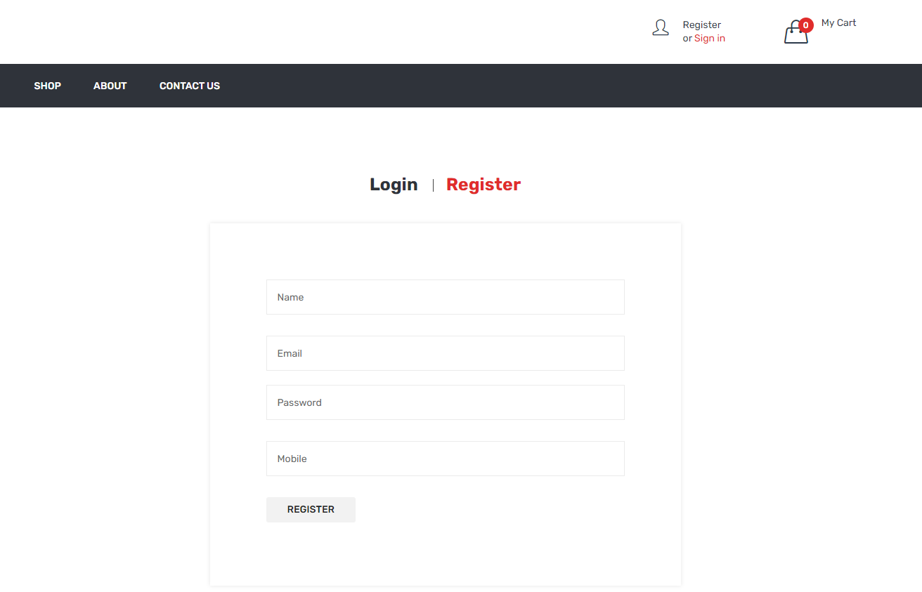

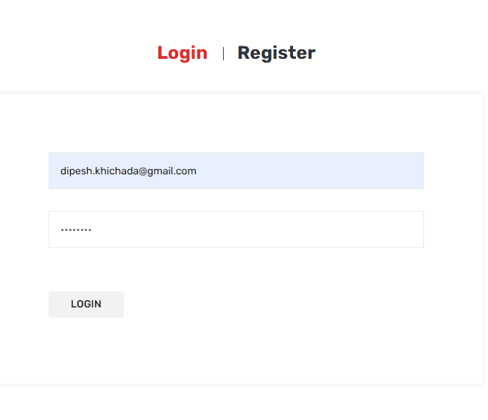

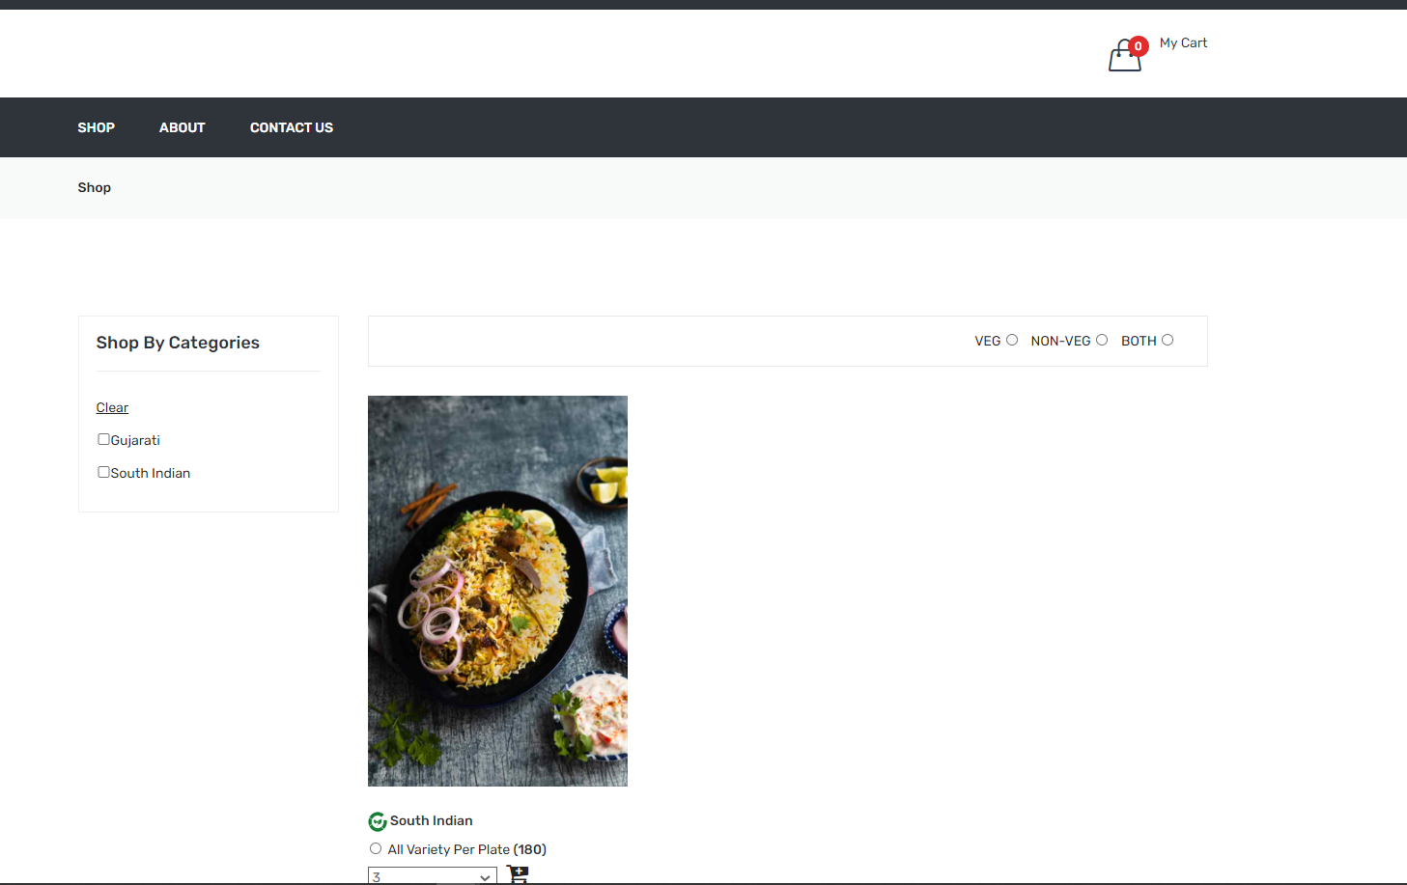

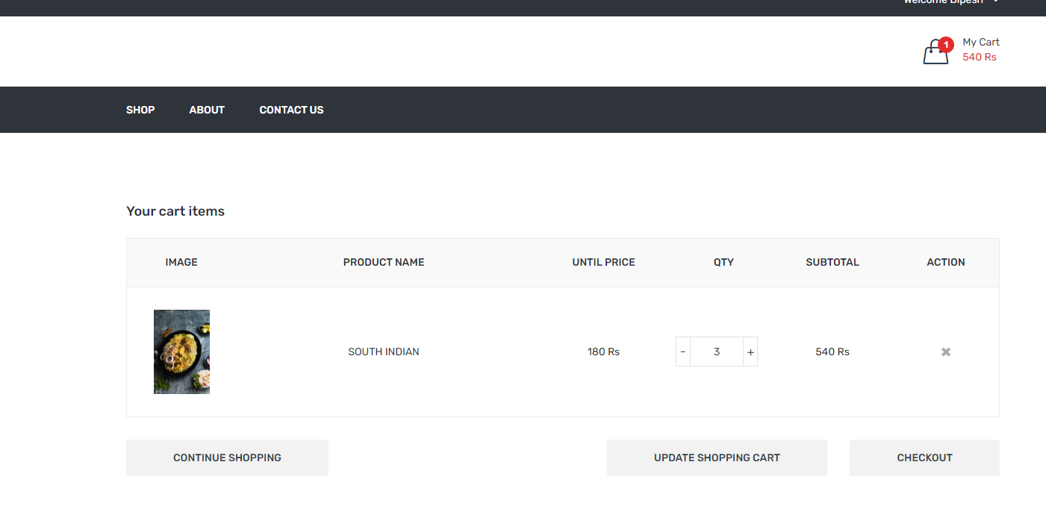

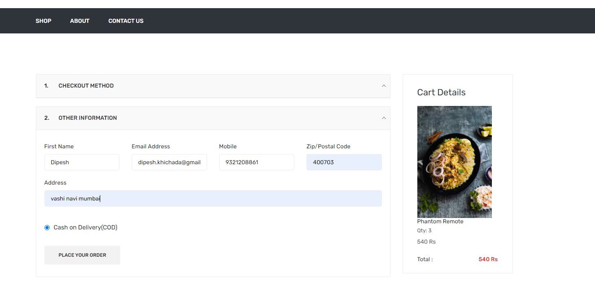

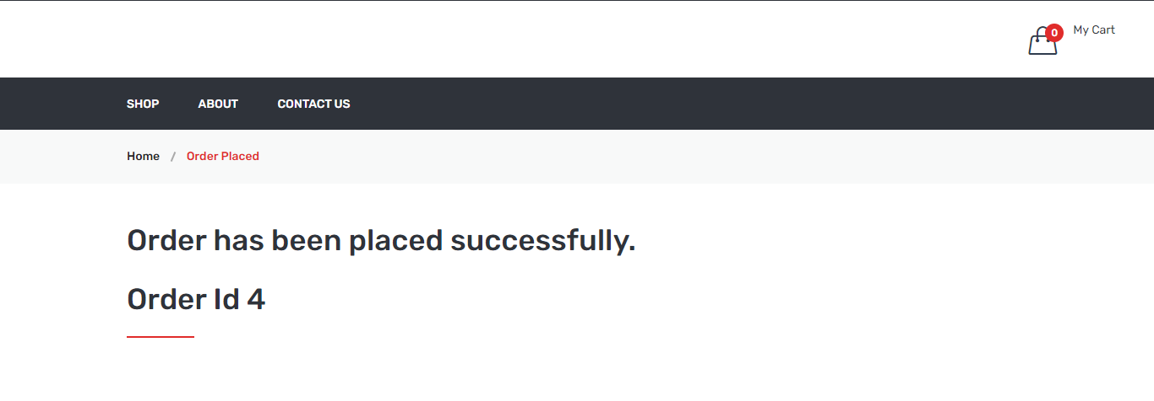

**Future Enhancement**

The following section describes the work that will be implemented with future releases of the software.

• Customize orders: Allow customers to customize food orders

• Enhance User Interface by adding more user interactive features. Provide Deals and promotional

Offer details to home page. Provide Recipes of the Week/Day to Home Page

• Payment Options: Add different payment options such as PayPal, Cash, Gift Cards etc. Allow to

save payment details for future use.

• Allow to process an order as a Guest

• Delivery Options: Add delivery option

• Order Process Estimate: Provide customer a visual graphical order status bar

• Order Status: Show only Active orders to Restaurant Employees.

• Order Ready notification: Send an Order Ready notification to the customer

• Restaurant Locator: Allow to find and choose a nearby restaurant

• Integrate with In store touch screen devices like iPad

# BIBLIOGRAPHY

# http://getbootstrap.com/

# https://www.youtube.com/watch?v=oepmLGQP1m4&list=PLUoqTnNH-2Xz_BUrjcahKWDhPcUj-FTOt

# http://www.javazoom.net/jzservlets/uploadbean/uploadbean.html

# https://javabrains.io/

# http://www.java2s.com/Tutorial/Java/0360__JSP/JSPDummyShoppingCart.html

# THANKYOU B.sc Computer Science Faculty